International Conference on Gender, Language and Education (ICGLE)
2 – 4 December 2020
The Education University of Hong Kong

EasyChair User Manual

ICGLE EasyChair: https://easychair.org/conferences/?conf=icgle2020
- If you have already used EasyChair before, please go to Step 2 (page 4).
- If you have never used EasyChair before, please go to Step 1 to create your EasyChair account (page).

Step 1: Create an EasyChair account
- Click the “create an account” button on the login page.

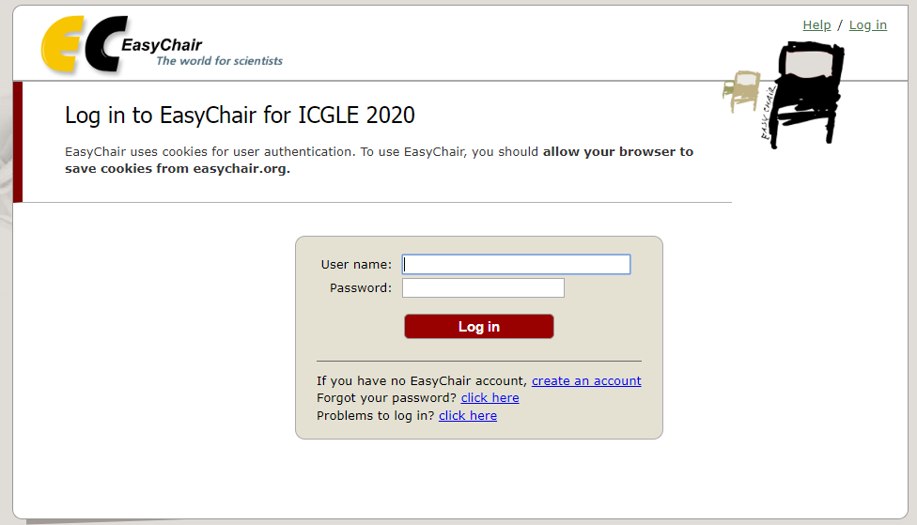

- Tick the box to confirm “I’m not a robot” and click “continue” to pass through the robot check.
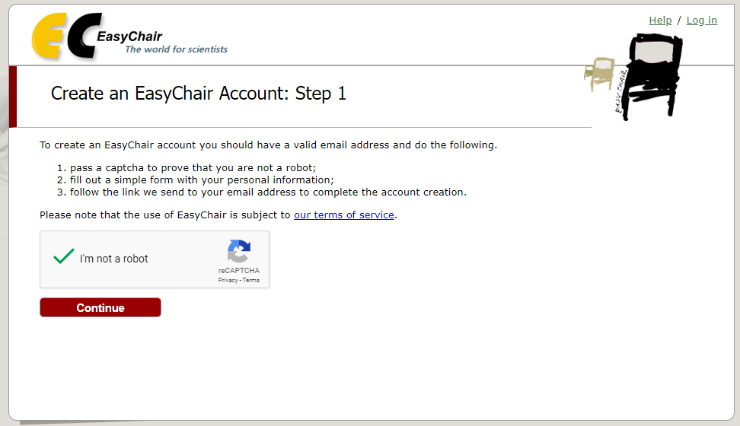

- Provide your name and email address and click “Continue” to create an EasyChair account.
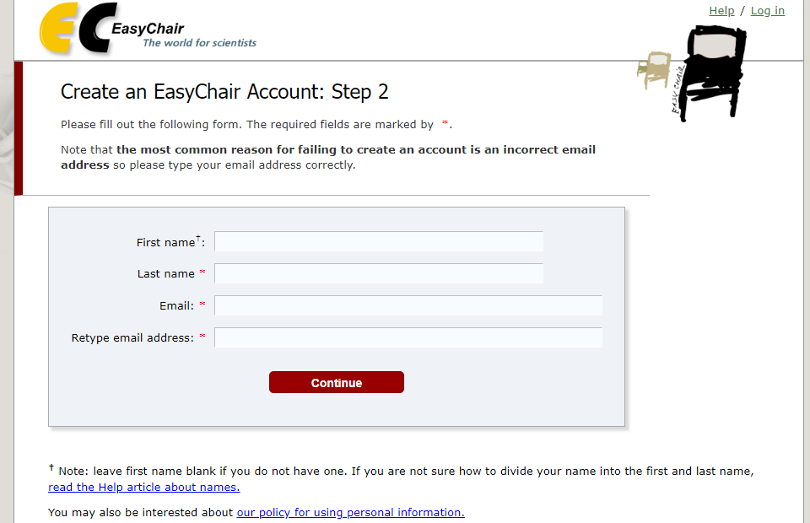

- A confirmation email will be sent to your submitted email address. Access the URL provided in the email and continue the account registration process.

- Complete your account registration by providing all the required information within 30 minutes. Then click “Create my account”.

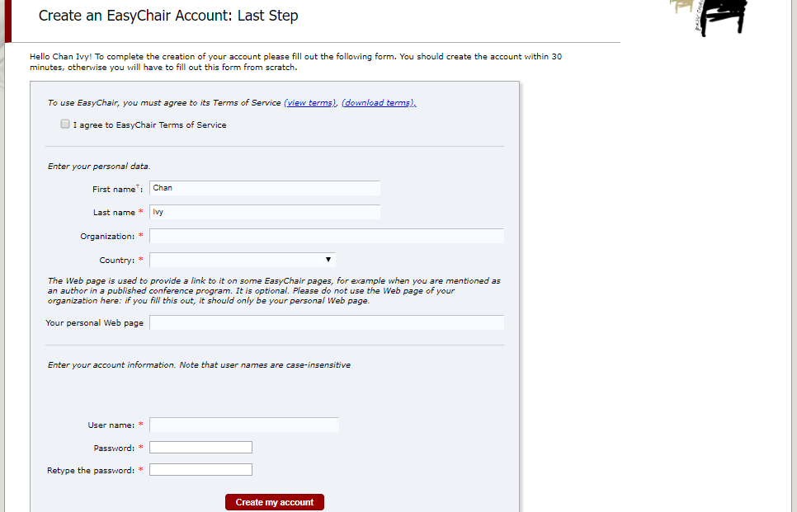
- Your EasyChair account has been created. Log in to access ICGLE 2020 by clicking “click here”.

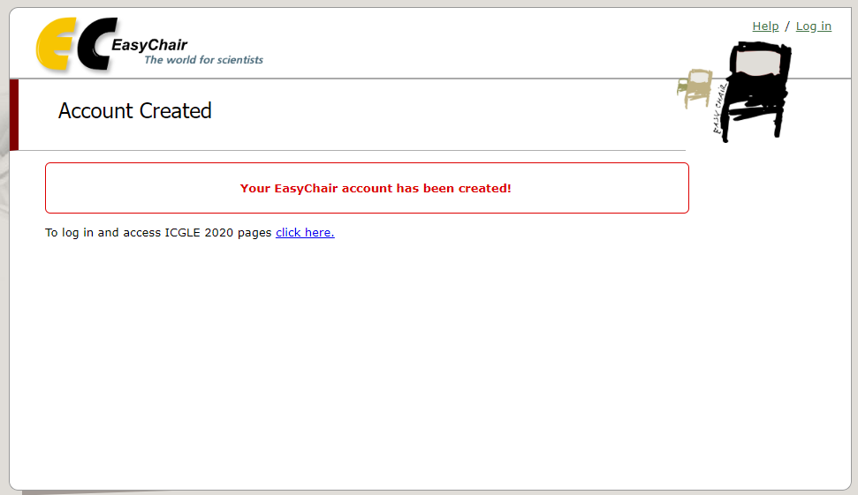

Step 2: Submit an abstract to ICGLE
- After logging in to your EasyChair account, you can make an abstract submission to ICGLE by clicking “enter as an author”.
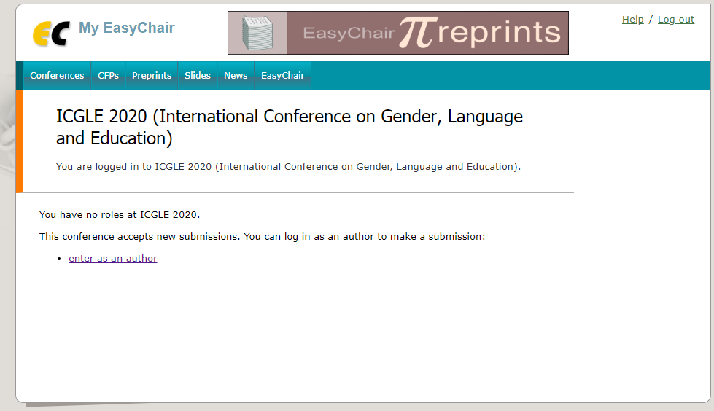

- Provide the author information as the first step of your abstract submission.
  - Please indicate the corresponding author(s) for your submission. The notification results will be sent to the corresponding author(s) only.
  - If there are more than three authors, please click “Click here to add more authors”.

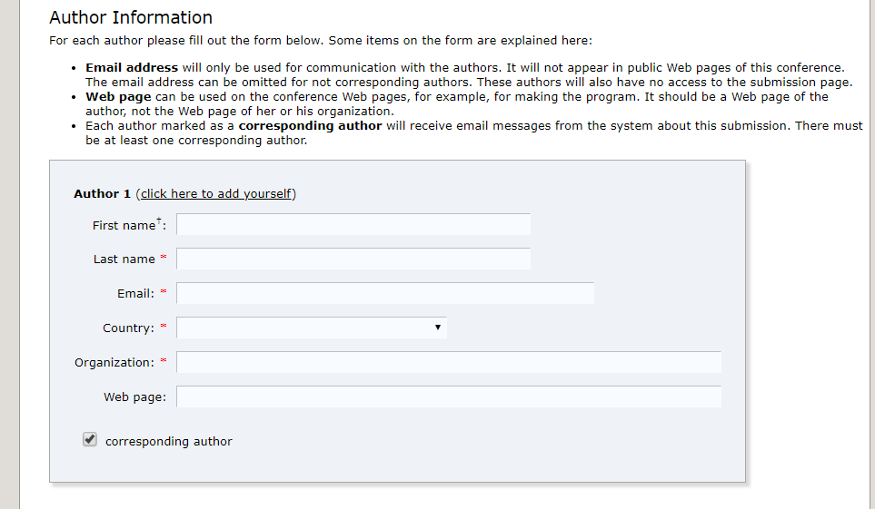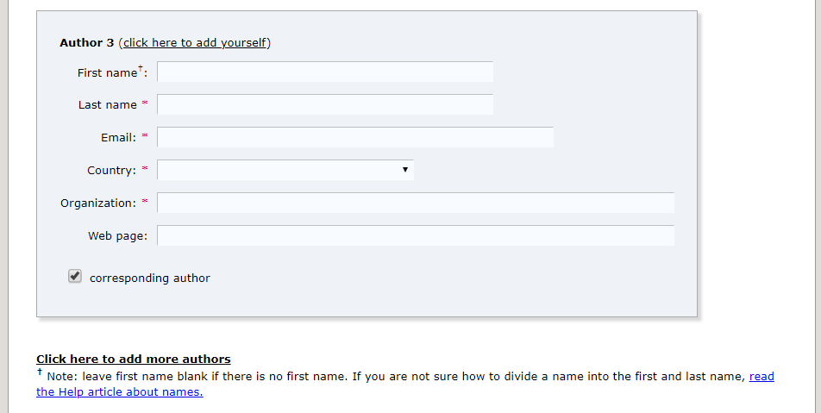

- Provide the submission details (i.e. Title, Abstract, Keywords). The abstract text should contain no more than 300 words, with at least 3 (or at most 5) keywords, one on each line. Authors should choose their preferred presentation format before submission.

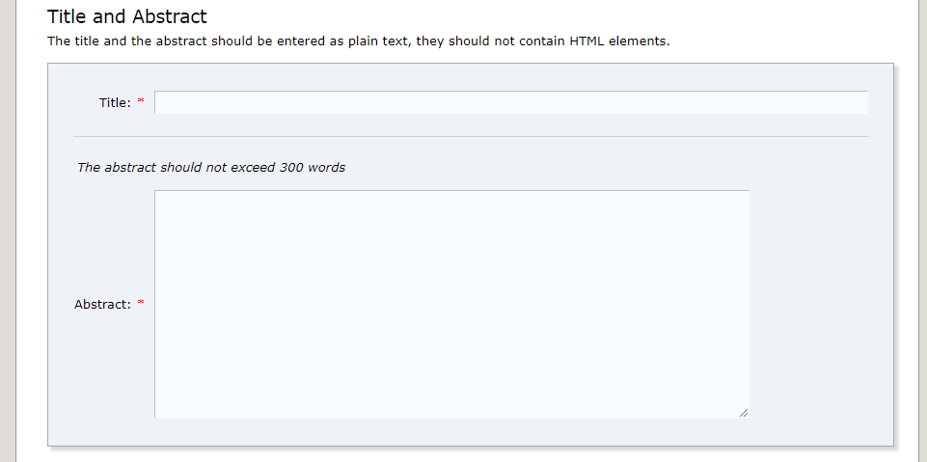
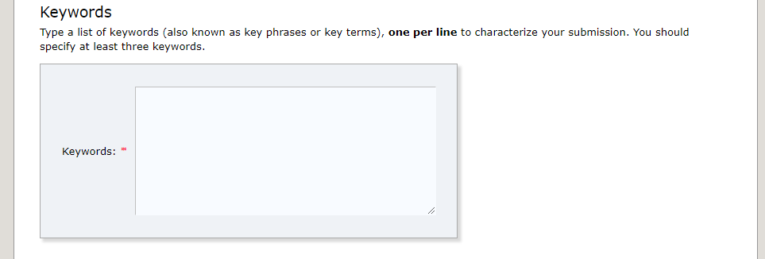
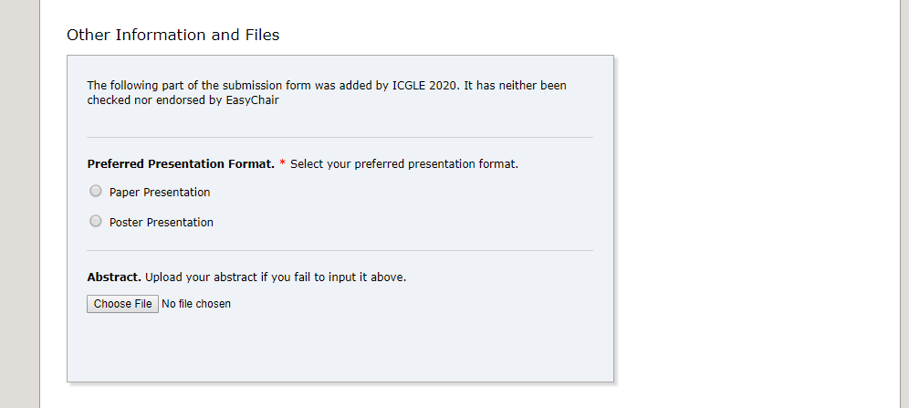

- A submission number will be produced if your submission is successful. You can check your submission details at any time. If you need to update your submission, click “Update information” on the vertical menu bar in the upper right corner. If you want to withdraw your application, click “Withdraw”. Please note that you will not be able to submit any abstracts or update your submission after the deadline (15 April 2020).

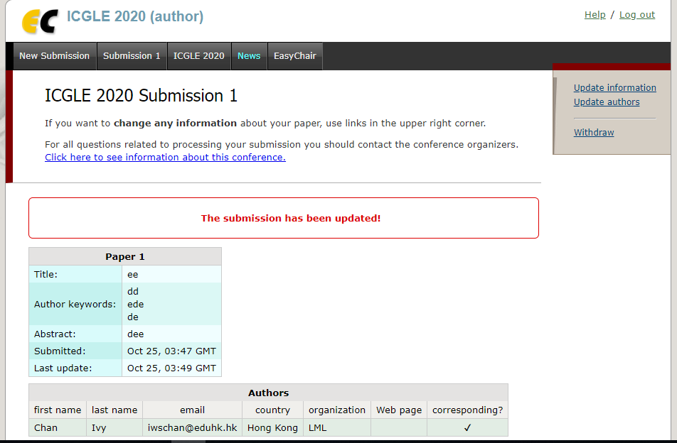

- An email notification regarding your submission will be sent to your registered email at the end of the process.

For conference-related questions, please email icgle2020@eduhk.hk.
Conference website: https://www.eduhk.hk/lml/icgle/
DEADLINE: 31 May 2020 (Sunday)

